

Name :
Abdullah Faroo

Roll no
FA-24-BCS-21

Subject
DSA La

Submitted To
Mam Min

Task A:
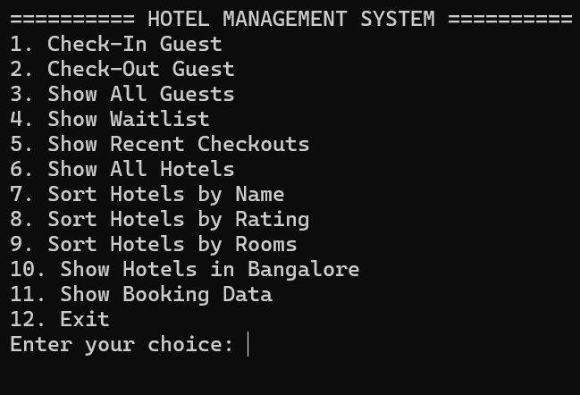
Task B: Output Verification
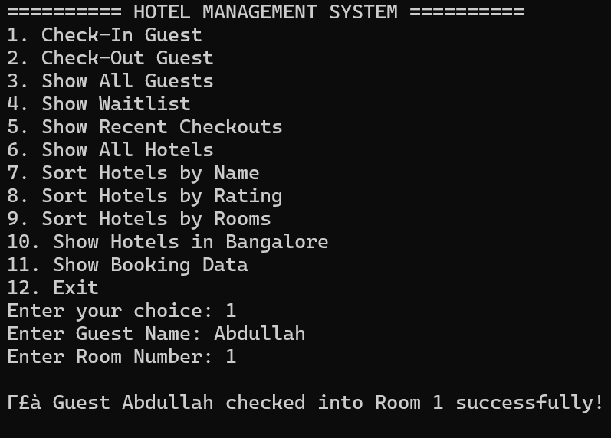

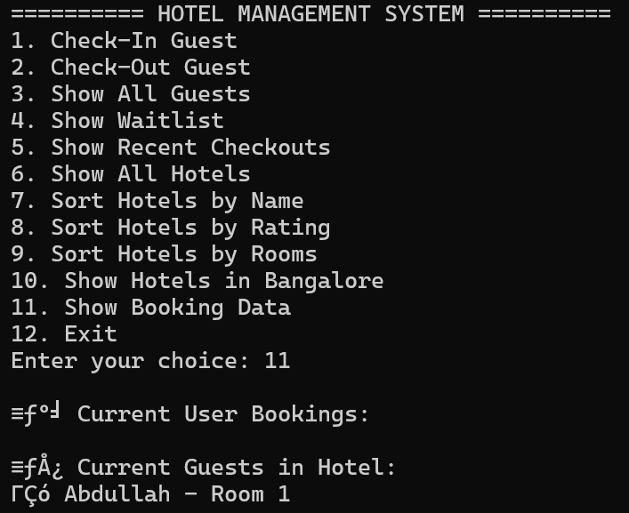

Task C: Kaizen Table

What was built | Problem or Limitation Found | Improvement Idea | Team Member Responsible | Expected Impact
Guest Record System ⁴ | Data is volatile; guest records are lost when the program closes . | Implement File Handling (I/O) to save guest data to a permanent file . | Ali Ibrahim (Organizer) ⁵ | Ensures data persistence for long-term hotel use.
Hotel Sorting Logic | Uses $O(n^2)$ sorting (Bubble/Selection), which is slow for large datasets . | Upgrade to Merge Sort or Quick Sort for $O(n \log n)$ efficiency . | Sattam (DS Wizard) ⁶ | Significantly improves performance when handling many hotels.
System Interface ⁷ | The console menu is text-only and prone to user input errors . | Design a Graphical User Interface (GUI) for better visual navigation⁸. | Abdullah (Sketch Artist) ⁹ | Enhanced user experience and professional appearance.
Search Function | Searching a Linked List for a guest name takes $O(n)$ time . | Use a Binary Search Tree (BST) or Hash Table for faster searching . | Sattam (DS Wizard) ¹⁰ | Faster retrieval of guest details during check-out.
Data Organization ¹¹ | The system manages tasks using simple Stacks and Queues¹². | Add an Automated Reporting System to export logs to Excel/CSV¹³. | Ali Ibrahim (Data Detective) ¹⁴ | Better business insights and auditing for management.

Task D: Eisenhower Matrix Planning
Urgency / Importance | Important | Not Important
Urgent | Quadrant 1: Do First  • Fix logic errors in checkOut function.  • Implement basic Data Structures (Array, Linked List, Stack) ².  • Submit Lab Assignment 01 by the deadline³³³³. | Quadrant 3: Delegate  • Sorting hotel data by location (Bangalore).  • Formatting the GitHub repository "Settings" page ⁴.  • Managing daily team check-in logs⁵.
Not Urgent | Quadrant 2: Schedule  • Upgrade to $O(n \log n)$ sorting algorithms.  • Add File Handling (I/O) for data persistence.  • Create a GUI (Graphical User Interface)⁶. | Quadrant 4: Eliminate  • Over-complicating the "Magical Stay" hotel story ⁷.  • Adding unnecessary visual emojis to console output.  • Excessive LinkedIn activity updates⁸.

Task E: GitHub Glow-Up
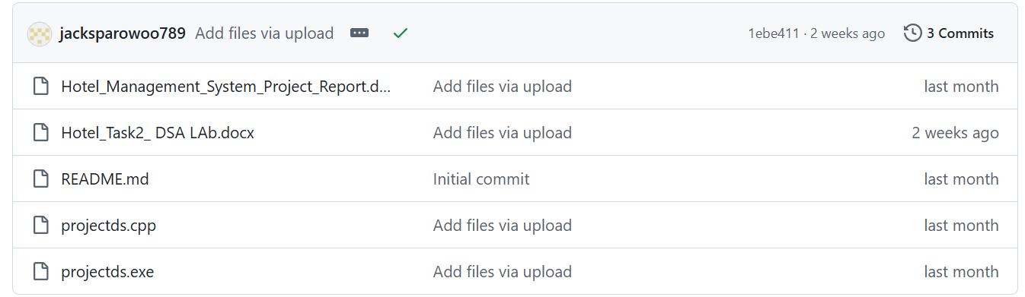
Task F: LinkedIn Networking
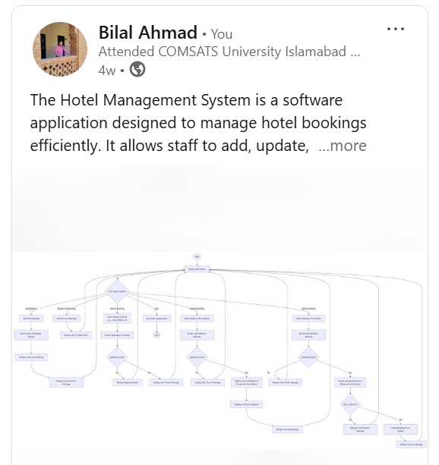

Task G: GitHub Link:
https://github.com/jacksparowoo789/Hotel-Management-Project-Java

